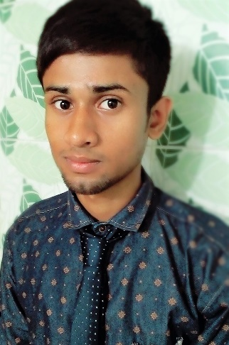**Curriculum Vitae**

Of

Md. Burhan Uddin

Mob: 01615707087

E-mail: burhanhossainmusa@gmail.com

**Career Objective:**

To secure a significant position utilizing my strong leadership in a reputed organization that is business oriented and implies to long term career growth. To full self-actualization by shouldering adequate organizational and organization goal as well as personal growth. To prove myself as a energetic person face any challenge where the contribution will be acknowledge, if I would be given an opportunity.

**Academic Career:**

**Current Institution:**

Name of University : Mirpur Govt. Bangla College

Subject : Mathematics

**Higher Secondary School Certification:**

Name of College : Bangabandhu Degree College

Result : GPA-4.42

Group : Science

Year : 2016

Board : Dinajpur

**Secondary School Certification:**

Name of School : Chandipur Bi-Lateral High School

Result : GPA-5.00

Year : 2014

Group : Science

Board : Dinajpur

**Skill and Abilities:**

* Have excellent command in Convincing people and Kids.
* Competent in dealing with internet Browsing.

**Language Proficiency:**

* Bengali is the mother tongue.
* Conversant and proficient both in written and spoken English.

**Personal Information:**

Full Name : Md. Burhan Uddin

Father’s Name : Md. Abdul Mannan

Mother’s Name : Most. Jesmine Begum

Present Address : House No:12,Road No:9, Mirpur-11

Dhaka-1215

Permanent Address : Village: Shitolpur, P.O: Bagduar

Upazila: Pirgonj,

Dist: Rangpur.

Date of Birth : 01/03/1998

Gender : Male

Nationality : Bangladeshi

Religion : Islam

Marital Status : Unmarried.

Height : 5’6”

Blood Group : O+

Hobby : Watching movie, Playing with Kids .

……………………..

Md Burhan Uddin

Date: